
n

Test Two

Semester One 2018
UNIT 1 METHODS

Calculator Free 40 minutes /40 marks

Formula Sheet is permitted
Name:

Place a tick in the box next to your Mathematics teachers name:

Mr Strain | □
Ms Sindel | □
Mrs Rimando | □
Mr Gannon | □
Mr Young | □
Mrs Flynn | □
Ms Ensly | □

Question 1 (4, 2, 2 = 8 marks)
Given ${\left(y+1\right)}^{2}=2x-1$ ,
- sketch the graph of the equation.

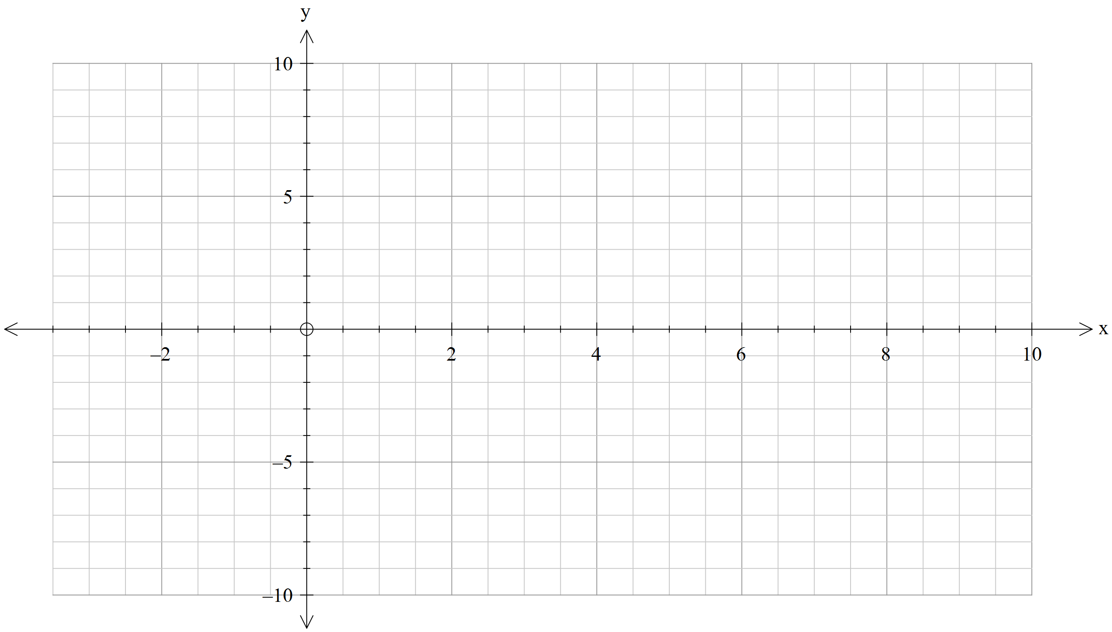

- state its domain and range.

- Is this graph a function? Justify.

Question 2 (4, 3 = 7 marks)

The function $f\left(x\right)=\sqrt{x}$ undergoes several transformations that result to $g\left(x\right)$ as represented in the graphs below.
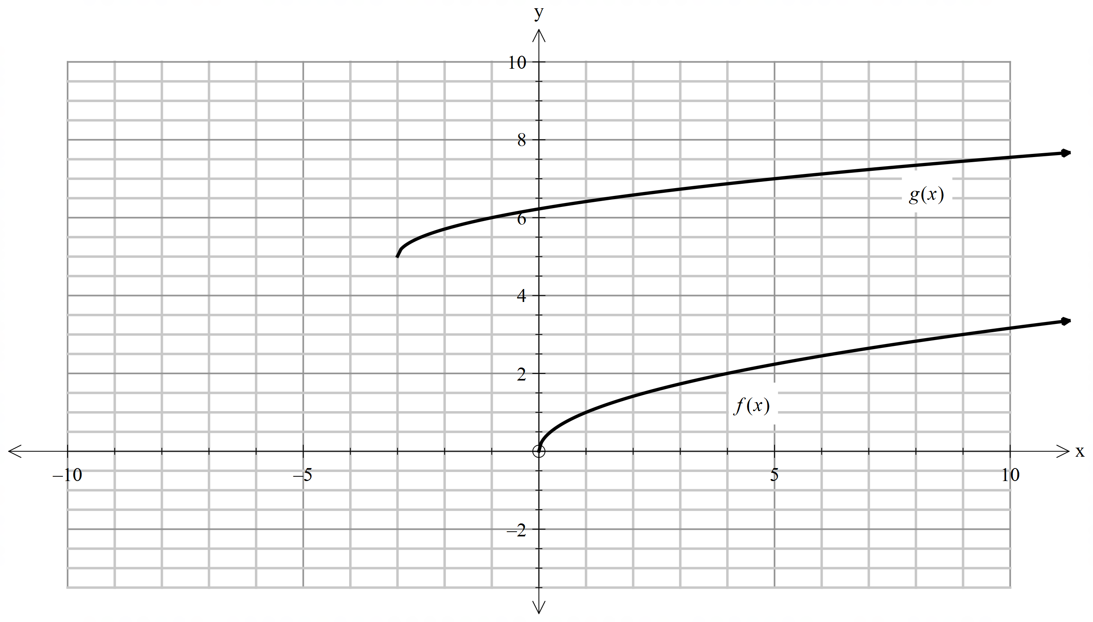

- Identify the order of transformations that would transform $f(x)$ to $g(x)$.

- Write the equation of the resulting function $g\left(x\right).$

Question 3 (2, 2 = 4 marks)

A circle has its centre at $(-2,-3)$ and passes through the point $\left(1,1\right).$

- What is the radius of this circle?

- State the equation of the circle in expanded form.

Question 4 (3, 3 = 6 marks)

Write the equations of the following graphs:
i)
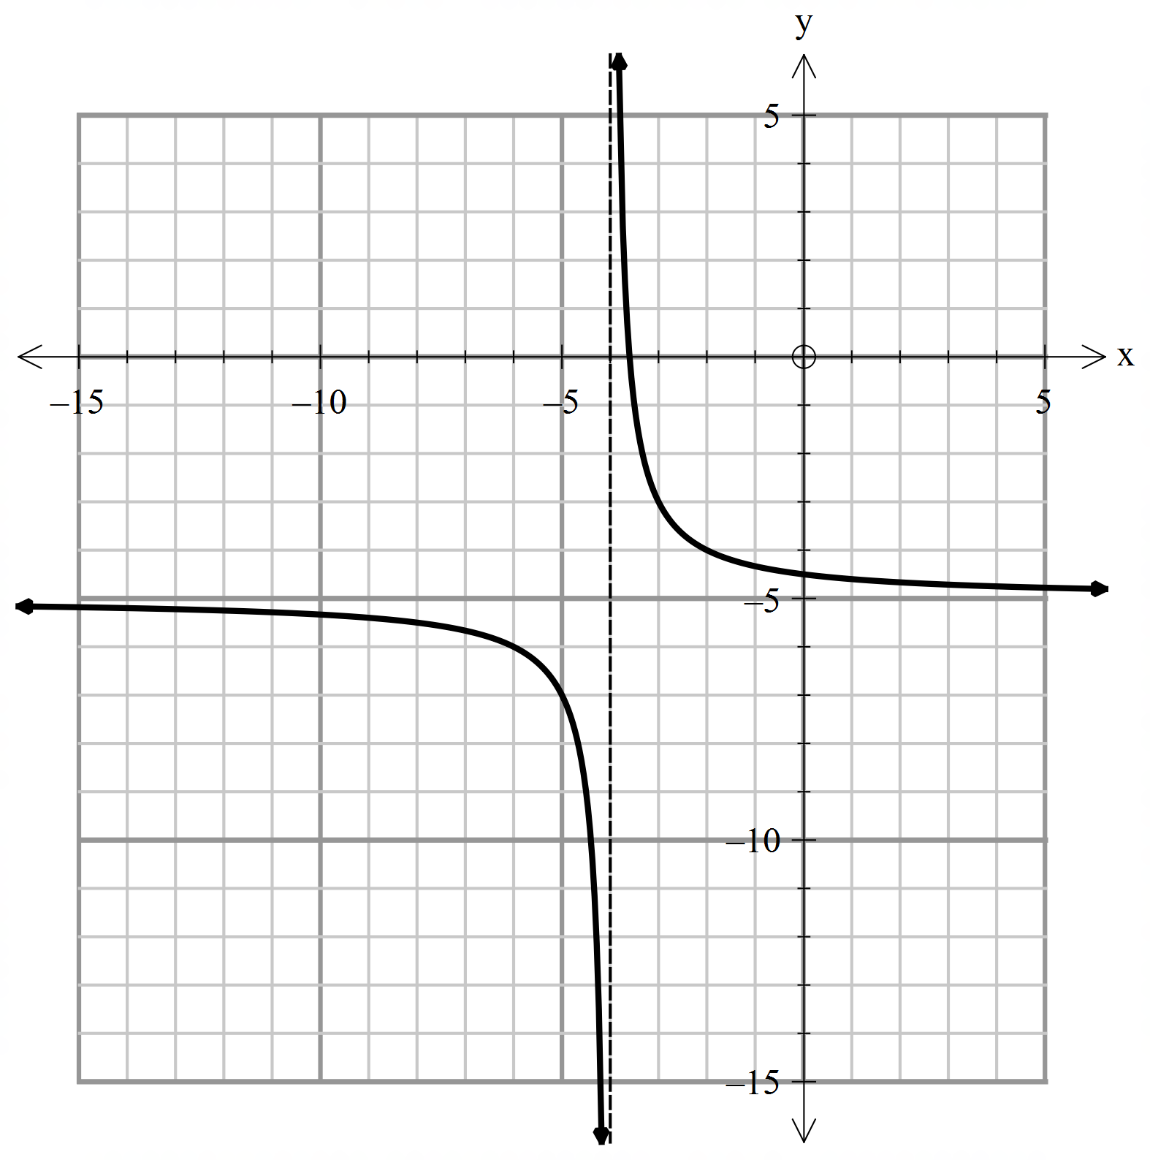
ii) 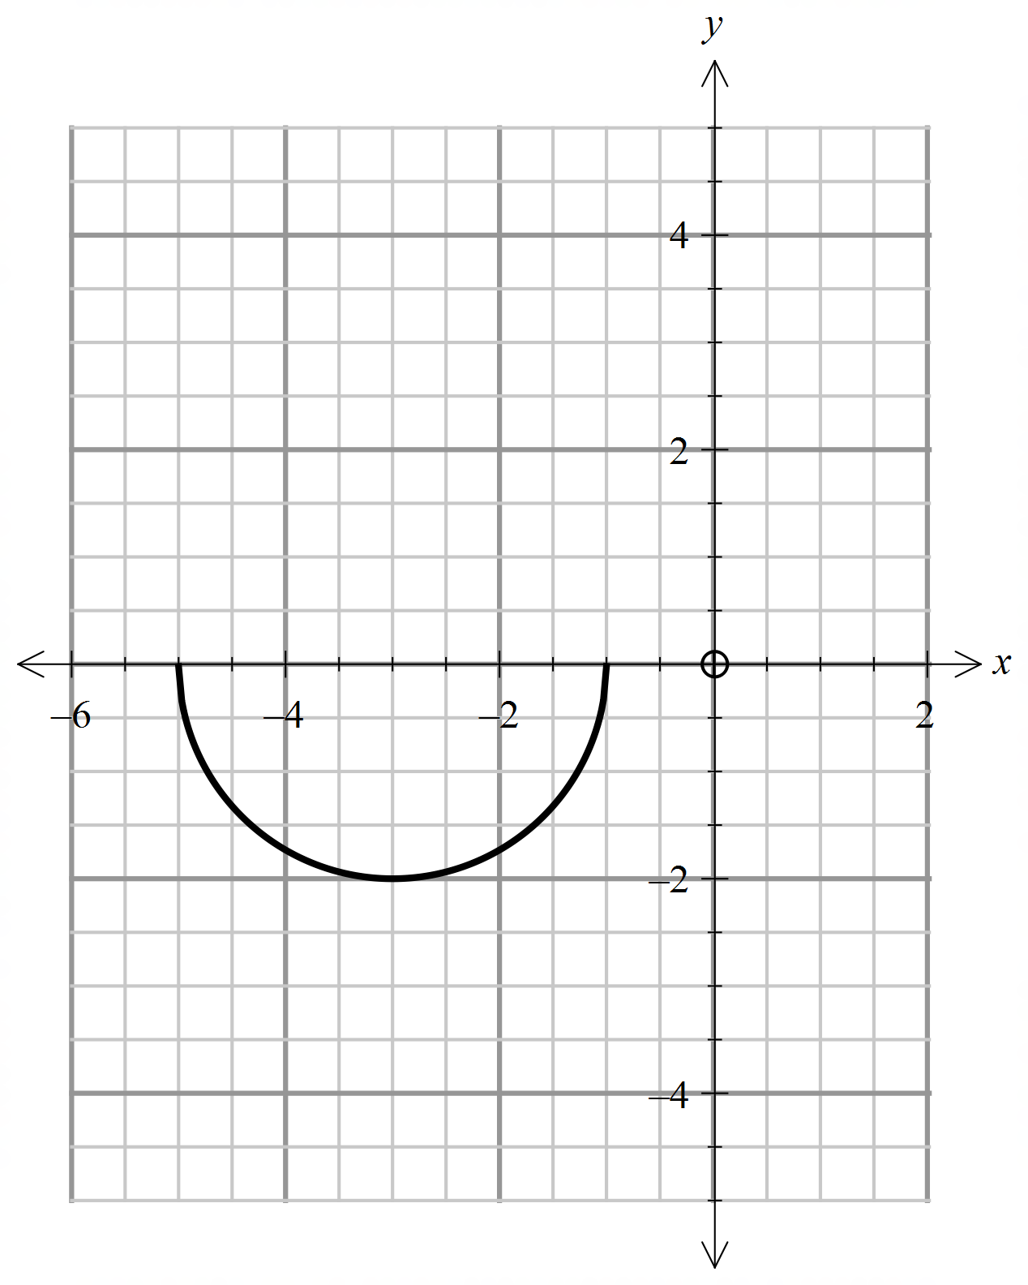

Question 5 (2, 2, 2 = 6 marks)

A pebble is thrown vertically upwards. It has an initial speed of $u$ metres per second. The pebble reaches a maximum height of $h$ metres before falling vertically downwards. It is known that $h$ is directly proportional to $u^{2}$. When the pebble is thrown with an initial speed of $10 m/s$, it reaches a maximum height of $5$meters.

- Write an equation that models this relationship.

- Calculate the maximum height reached when the pebble is thrown with an initial speed of $12 m/s$.

- Find the initial speed of the pebble if the maximum height reached is $16$ meters. Write your answer as an exact value.

Question 6 (4 marks)
State whether the relationships given below model a direct variation, inverse variation or neither.

- $y=7x-2$

- The number of hours to finish a job and the number of workers.

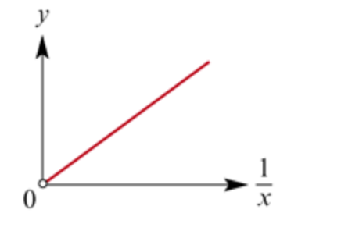

x | 1 | 2 | 3
y | 5 | 2.5 | 1

Question 7 (1, 4 =5 marks)

There are 100 people in an evacuation centre. Supplies for food are being rationed and their supply will last for 20 days.

- Write a variation statement that relates the number of days for food supplies $f$, to the number of people, $p.$

- Suppose 25 more people are evacuated in the same centre. At the very latest, on what day should their supplies be replenished?

End of test

